➢➢ Explanation :
- To find the square of a number we multiply the number with itself.
- Store the result.
➢➢ Algorithm :
Step I : Initialize the look up table pointer.
Step II : Initialize the source memory pointer and destination memory pointer.
Step III : Get the number.
Step IV : Compute the square of number. Result is stored in the A register.
Step V : Store the result to the required destination location.
Step VI : Increment source memory pointer.
Step VII : Increment destination memory pointer.
Step VIII : Check if number is last number. If not goto step III
Step IX : Stop.
➢➢ Flowchart : Refer flowchart 32.
➢➢ Program :
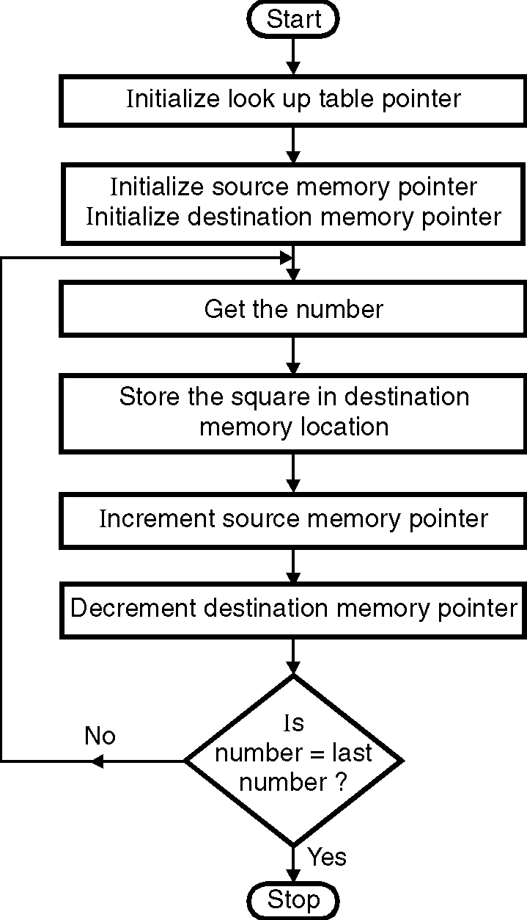
Instruction Comment
LXI H, D100H ; Initialize lookup ; table pointer
LXI D, D000H ; Initialize source
; memory pointer
LXI B, D200H ; Initialize
; destination
; memory pointer
BACK: LDAX D ; Get the number
MOV L,A ; A point to the
; square
MOV A,M ; Get the square
STAX B ; Store the result
; at destination
; memory location
INX D ; Increment
; source memory pointer
INX B ; Increment destination
; memory pointer
MOV A,C
CPI 05H ; Check for last number
JNZ BACK ; If not repeat
HLT ; End of program
Flowchart 32

